Stochastic Search for a Target on a Textured Background

A. D.F. Clarke, P. R. Green & M. J. Chantler

We present a comparison between human search performance and that of a stochastic model. The model uses the results of a Signal-Detection style experiment to model target detectability and makes random saccades, weighted by empirically derived saccade amplitude distributions. We find that the model compares well with human performance despite having not integrating information across successive fixations or keeping track on previously fixated image regions.

# Introduction

A complete computation model of visual search should contain two parts: a feature extraction mechanism and a search strategy. The feature extraction stage takes information from the stimuli and processes it to give an activation map. This process can take guided search into account (Wolfe, Cave, & Fransel, 1989; Wolfe, 1994; Wolfe & Gancarz, 1997; Wolfe, 2007) along with bottom-up saliency effects (Itti & Koch, 2000; Gao, Mahadevan, & Vasconcelos, 2008; Itti & Baldi, 2008). The search strategy part of the model uses this information to decide where to fixate next. While a number of different mechanism for this have been put forward the most commonly implemented is the MAXP Observer (Najemnik & Geisler, 2005). This strategy directs saccades to the local maxima of the activation map and has been used in models by Rao, Zelinsky, Hayhoe & Ballard (2002) Pomplun, Reingold & Shen (2003), Rutishuaser & Koch (2007), Clarke, Green & Chandler (2009) among others. An alternative to the MAXP Observer is the Ideal Observer which Najemnik & Geisler have derived for a search task involving a target hidden in $1/f$-noise (2005; 2008).

All the above models assume that human observers implement a very systematic search strategy. However human scan-paths appear to contain a large degree of randomness. Motter and Holsapple (2001) demonstrated that chance plays a significant role in visual search performance in monkeys when searching for a T among L’s (and vice versa). While this chance component decreases as the number of distracters increase, it continues to account for a sizeable fraction of performance. Random walks have been successfully used to model an observer’s speed and accuracy in present/absent forced choice experiments. (Stone, 1960; Reeves, Santhi, & DeCaro, 2005) Rather than model the spatial distribution of fixations these models simulate the observer’s decision making process. The random walk occurs between two boundaries one for a target present response and one for target absent, and is governed by a drift and bias.

Aks et al have argued that the presence of $1/f$ dynamics in saccade-time series is evidence of memory and a systematic component in visual search (Aks, Zelinsky, & Sprott, 2002; Aks D. , 2005). They also carried out the same time-series analysis on a random walk found that it did not exhibit the same properties. However the details of the precise nature of the random walk and following comparison were not included in the paper. Furthermore, it is possible that Aks’ result is an artefact of studying the compound time-series of large number of visual searches, one after another. It has been shown that a coarse-to-fine dynamic are often present in saccade patterns during search (Over E. A., Hooge, Vlaskamp, & Erklens, 2007). If we were to look at the saccade amplitude time-series of several individual searches, each with a coarse-to-fine dynamic, then we would expect to see a strong low frequency component which could, at least partially, explain Aks et al.’s result.

Greene showed that the distance-from-target dynamics noted by Tseng and Li (2004) also arise in simple random walk simulations (Greene, 2008). Green’s random model generated saccades at random with a constraint on the saccade amplitudes such that they were between 20 and 50 pixels wide. The target as assumed to be detected if it was within 20 pixels of the current fixations, and the model was given a maximum of 15 saccades to find the target.

Visual search is often viewed to be in some sense systematic: Wolf’s Guided Search Model assumes that observers will direct their attention towards search items which share properties with the target; saliency algorithms direct saccades towards image regions which differ from their local surroundings (Itti & Koch, 2000; Itti & Baldi, 2008; Gao, Mahadevan, & Vasconcelos, 2008); and ideal observers work on the assumption that saccades should be directed to the region which will maximize the likelihood of then finding the target (Najemnik & Geisler, 2005; 2008). On the other hand, other studies have suggested that stochastic processes such as random walks can explain many aspects of visual search (Motter & Holsapple, 2001; Greene, 2008). A number of models ranging from completely random to systematic have been derived, however they have not been validated against empirical data (Morawski, Drury, & Karwan, 1980; Arani, Karwan, & Drury, 1984; Melloy, Das, Gramopadhye, & Duckowski, 2006).

In this study we look at how well a simple data-driven model, which uses a stochastic process to generate saccades, can explain human performance in a search task involving a target on a homogeneous textured background (see Figure 1 for an example).



Figure : An example of a $1/f^{β}$-noise textured surface with a target.

This search task appears to be somewhat neglected in comparison with the more traditional task of searching for a discrete target item among distracters. However using a continuous[[1]](#footnote-2) textured background as a distracter has a number of advantages (Clarke, Green, Chantler, & Emrith, 2008). Firstly, these images are in some sense more naturalistic than arrays of discrete items. Secondly, unlike photographs we can create as many different yet statistically equivalent textures, which is useful when running psychophysics experiments. A final property of these stimuli is that the difficulty of the search task is controlled by only two factors: the saliency of the target against the textured background, and its distance from the centre of the image (Clarke, Green, & Chantler, 2009).

Most saccade based search models assume that search is largely systematic and are based on Wolfe’s Guided Search (Wolfe, 1994; Wolfe & Gancarz, 1997; Wolfe, 2007; Pomplun, Reingold, & Shen, 2003; Rutishauser & Koch, 2007; Clarke, Green, & Chantler, 2009; Tavassoli, van der Linde, Bovik, & Cormack, 2009). Guided Search assumes that an *activation map* is generated pre-attentively which promotes top-down target relevant regions along with those that are salient (Itti & Koch, 2000).

Several more general tendencies have been taken to be indicative of systematic search strategies. Gilchrist and Harvey argue that the presence of a horizontal bias in saccade directions indicates the presence of a systematic component in visual search (Gilchrist & Harvey, 2006). They suggest that systematic tendencies can be hard to detect in scan-paths because of the interaction with salience-based object selection.

One theory of search strategies makes use of the idea of the Bayesian Ideal observer (Najemnik & Geisler, 2008). Najemnik and Geisler based their model on visibility maps calculated from empirical data collected during a signal detection experiment. This visibility is used to control how much noise is added to potential target locations (more noise at higher eccentricities) in the simulations. The Ideal Observer then makes saccades to the target location which will *maximise the likelihood of it being able to identify the target in the following saccade*. This contrasts with strategies where the model makes a saccade to the location which is currently most likely to be the target.

## Previous Work

In our previous work we have applied an LNL-based model to the problem of modelling search for a target on a rough surface (Clarke, et al., 2009). A bank of Gabor filters were applied to the input image and then passed through a non-linearity. This nonlinear processing strengthened the signal of filter response maps containing a small number of strong local maxima (as opposed to maps which contained a large number of local maxima). Finally these feature maps were passed through a 2nd order linear filter (local energy pooling) before being summed together to give an activation map. This activation map was then passed to a simple saccade selection algorithm. For each fixation an exponential distance dependant fall-off was applied to the activation map along with a simple inhibition of return process. The model would then randomly select one of the $n$ (=3) largest local maxima as its saccade target.

While the algorithm succeeded in modelling human performance (in terms of the number of saccades required to find the target), it fails to predict saccade targets: there does not appear to be a relationship between human fixation locations and (non-target) local maxima in the activation map. (See **Error! Reference source not found.**). As the example shows, human observers often make long saccades that can not be explained using our eccentricity dependant exponential fall-off. While one possibility would be that the fall-off function is too strong, we can discard this suggestion as weakening the activation fall-off function would cause the model to diverge from human performance in terms of number of saccade to targets at high eccentricities.

To explore this further we compared saccade targets for the model with those chosen by human observers. Over all observers, trials and fixations, 22% of saccades were directed to within $1^{∘}$ of one of the three saccade targets considered by the model. While this appears promising, over 25% of human saccades fall over ${4.3}^{∘}$ (=a quarter of the stimulus’ length) away from the nearest point considered by the model.

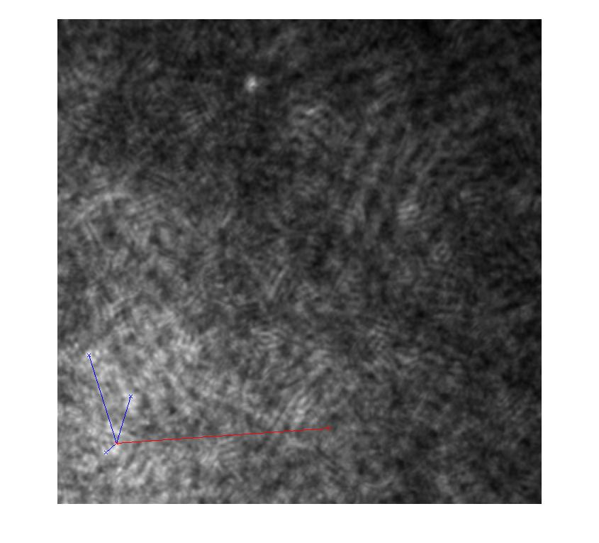

Figure : An example activation map from the LNL search model (Clarke et al. 2009).The target can be seen near the top of the image. The current fixation location is near the bottom left corner which appears brighter than the rest of the image due to the eccentricity dependant fall-off in activation. The blue lines show the three saccades considered by the model, and the red line shows the actual saccade taken by the human observer.

Furthermore, a large amount of the model’s success can be accounted for my chance. Let us assume:

* that all (both the model’s and human) saccades are no more than $r$ in amplitude.
* the three saccades considered by the model are separated from each other by at least $2^{∘}$.

Then the fixations will occur somewhere within an circle with area $A=πr^{2}$. Therefore the probability of the human saccade landing within $1^{∘}$ of one of the model’s saccades is $p=\frac{3π}{A}=\frac{3}{r^{2}}$. If we take $r=4^{∘}$ (over half of the human saccades are under $4^{∘}$ in amplitude) then we would expect the human observers to fixate one of the regions selected by the model 19% of the time.

The above analysis suggests that the LNL-model, while offering a good prediction of the perceived difficulty of the search task, does not succeed in modelling saccade selections any better than a random model would. The aim of this study is to examine the extent to which human performance in surface/target search task can be explained by a random walk model. We will use similar methods to Najemnik and Geisler in order to construct a *target detection* model based on the results of a signal detection experiment. This will then be used in conjunction with a stochastic process which draws saccade amplitude and directions from empirically derived distributions.

There are two key differences between the stimuli used by Najemnik and Geisler and ours. Firstly they used $1/f$-noise as their stimuli where as we have combined $1/f$-noise with an illumination model to give surfaces that appear naturalistic (Clarke, Green, Chantler, & Emrith, 2008). Secondly, they only consider 85 potential target locations. While we would not expect human observers to notice this, it does considerably simplify the derivation of the Ideal Observer. If the target is allowed to be positioned anywhere in the stimuli then the independence assumption is no longer valid.

# Experiment One – Signal Detection

The aim of this experiment is to measure the probability of target detection for different eccentricities and surface roughness combinations. This will then give us a simple model for the probability of target detection at different eccentricities and surface roughnesses.

## Stimuli

A range of rough surfaces were generated by applying Lambert’s cosine law to height maps generated by a $1/f^{β}$-noise process. For full technical details see Clarke et al. (2008). The surface roughness is governed by $β∈\left\{1.60, 1.65, 1.70\right\}$ and a scaling factor, RMS roughness, which was kept constant, $σ_{RMS}=1.1$.

For the target present trials, the target was located at one of 72 potential locations: nine different eccentricities where used ${ 0.84}^{∘}≤r≤{7.5}^{∘}$, and eight evenly spaced orientations. (For an example, see **Error! Reference source not found.**). The target was made by subtracting an ellipsoid from the three dimensional surface and subtended ${0.66}^{∘}$ of visual angle.

For each parameter combination, twenty different trials were created (by changing the random seed used to create the noise we can create different, yet statistically identical textured surfaces). Additionally, 160 target absent trials were included for each value of $β$. This gave a total of 2160 target present trials and 480 target absent. (The number of target absent trials to include was based on pilot results to ensure that observers made roughly equal positive and negative responses. As a large number of the target present trials are answer incorrectly we do not need so many target absent trials.)

## Method

Two participants carried out all the trials, split into twenty subgroups, over a number of days. They were paid £50 each.

Within each subgroup of 132 trials there were 33 runs of 4 trials. During each run the participants were instructed to keep their eyes fixated on the centre of the image. Each trial consisted of a fixation cross (500ms), stimuli (200ms), white noise mask (500ms), and finally a fixation cross is displayed until a target present or absent response is given.

## Results

Trials in which fixation was not held at the centre of the image (14%) were removed from further analysis. The results for the two individual participants are shown in Figure **Error! Reference source not found.**3. For all cases, the accuracy for the target absent trials is >90%, and hence will false positives will not be included in any further analysis.

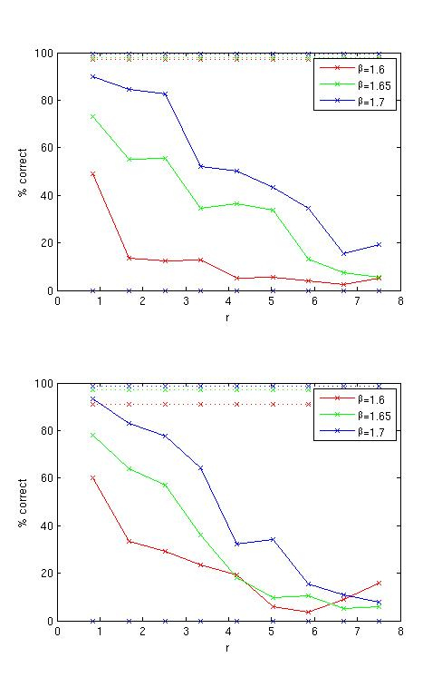

Figure : Results for the two participants

The mean target present performance is shown in **Error! Reference source not found.**. We will model this by using a simple multi-linear model:

$$p\left(T|β,r\right)= 4.09β-0.11r-5.97$$

This regression model gives $R^{2}=0.934$.

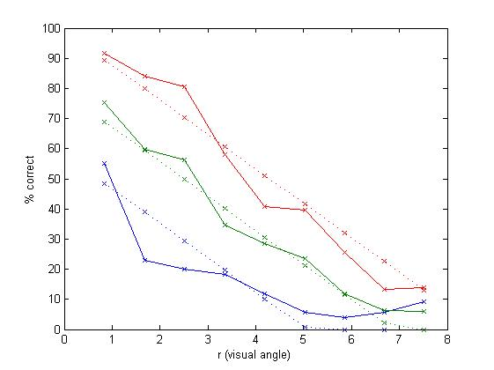

Figure : Combined results, and the multi-linear regression lines

### Discussion

The two subjects performed similarly and the mean detection performance can be modelled using a multi-linear model with $β$ and $r$ ($R^{2}=0.934$).

# A Simple Simulation

In this section, in a similar way to Najemnik and Geisler’s Ideal Observer model (2005; 2008), we use the results of the signal detection experiment as the foundation of a simple search model. The linear-regression detection model will be used with data on human saccade distributions taken from previous work.

## Human Saccade Distributions

In this section we will overview the first of Clarke et al.’s visual search experiments (2009). This experiment involved similar stimuli to those described above, although only 3 different target eccentricities were used. Seven observers completed the experiment and the task was simply to press a button on the keyboard once the target had been found. They were given unlimited time and an eye-tracker was used to monitor fixation locations. As the surface was made rougher (decreasing $β$ and increasing $σ_{RMS}$) a greater number of saccades were required to find the target. We will now carry out some further analysis of this data set.

The global saccade amplitude and direction distributions are shown in **Error! Reference source not found.**. As we can see, the saccade directions show the same horizontal bias as reported by Gilchrist & Harvey (2006) and Najemnik & Geisler (2008). The saccade amplitude-time series is shown in **Error! Reference source not found.**. Again our data follows previously reported trends: in this case, a coarse-to-fine search strategy reported by Over et al. (2007).

We will use these empirical distributions for generating saccades in our random walk. For each saccade number $t, 1≤t≤50$ we will draw a saccade amplitude from the distribution of amplitudes made by human observers on the $t$ th saccade of a visual search. If the model needs to make more than 50 saccades to find the target, it will simply draw amplitudes from the distribution for $t=50$.

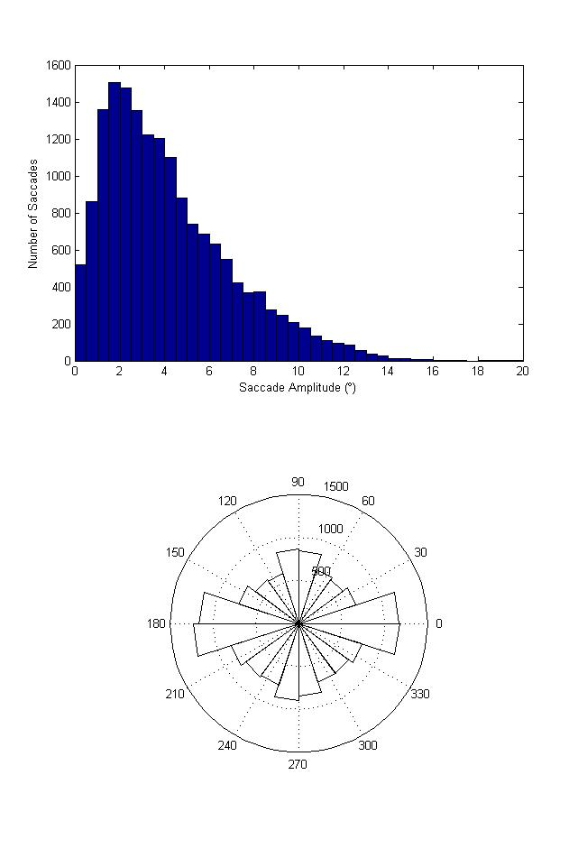

Figure : Saccade Amplitude Histogram and Directional Rose Plot.

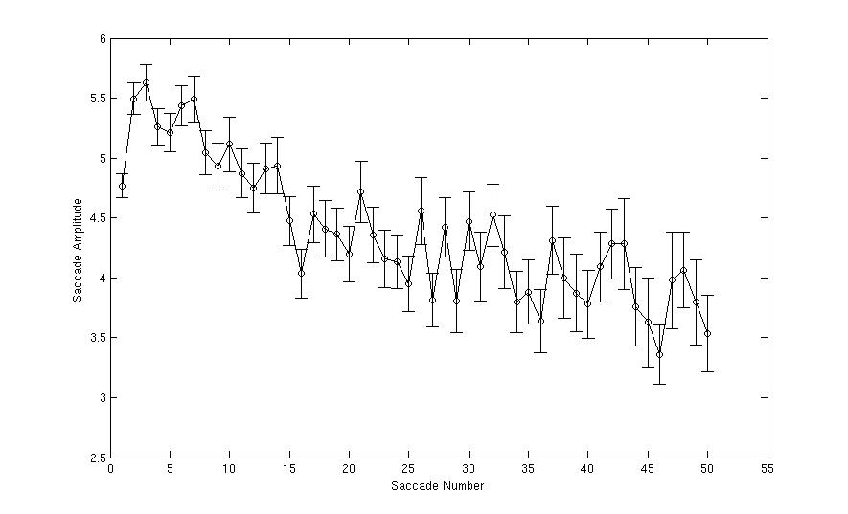

Figure : The saccade amplitude time series.

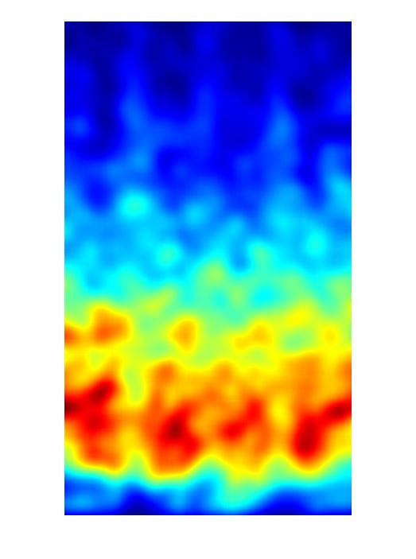

Figure : Hotspot map showing saccade direction/amplitude distribution

## Algorithm

### Inputs

The model is given $N$, the size of the search area, $β$, the roughness of the surface, and the targets location (chosen randomly for a given eccentricity $r$). The initial fixation is set to the centre of the search area.

### Target Detection

Specifically, on each fixation the probability that the model detects the target is given by $p=f(β,r)$ where $r$ is the distance from the current fixation to the target, $β$ governs how rough the surface is, and $f$ is the linear regression model of the results in Experiment One. For each fixation we simple generate a random number $x∈[0,1]$ and check to see if $x≤p$, in which case the model detects the target, makes a saccade to the target’s location, and the search is terminated. If the model does not detect the target ($x>p$) then a random saccade is made to a new location.

### Generating a Saccade

In order to generate human-like scan paths we will use the empirical saccade direction distribution as a probability density function. As the empirical saccade amplitude distributions vary over time we will … (not sure who to word this clearly). The model is allowed to make a maximum of 200 fixations.

## Results

We see that the simple random searcher performs in a similar way to the human observers (Figure 8). While it finds the target in less fixations than the mean human observer, if we compare the individual observers with the model in each condition we see that the model is well within the range we would expect from a person (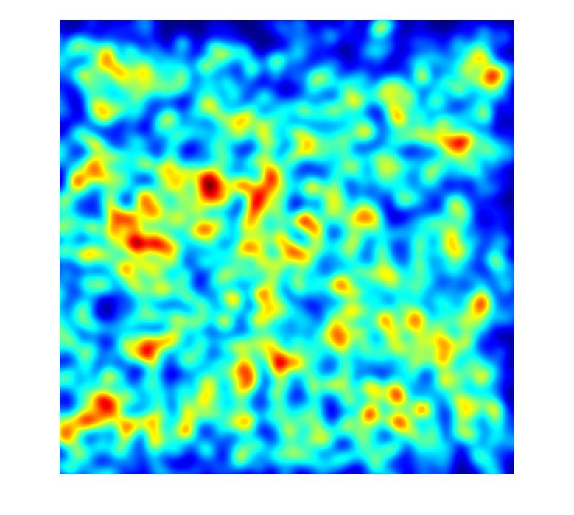9).

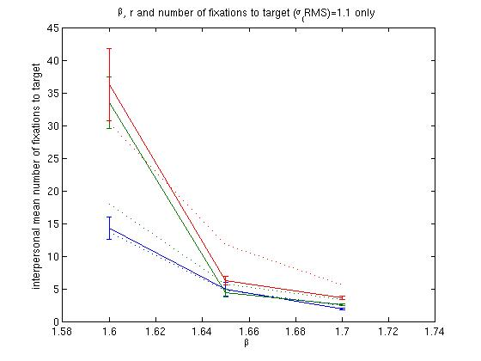

Figure : Number of fixations required to locate the target. Solid line - interpersonal mean for human observers. Dashed line - random walk simulation

Figure : Mean number of saccades required to find the target for the 7 individual observers (blue) and the stochastic search model (red).

One of the main arguments put forward by Najemnik and Geisler for the use of an Ideal Observer over a MAXP strategy is based on the spatial location of fixations. They found that that both human observers in their experiment showed a pronounced bias for making fixations above and below the stimulus centre. Due to the horizontal bias in the visibility map they used, their Ideal Observer behaved in the same manner: if visibility is greater along the horizontal axis then a vertical saccade will give us the most new information. For the same reason, a MAXP type observer will tend to make more horizontal saccades. As this argument could be used to discount our random walk model we have investigated the spatial locations of fixations in our data, over all observers and trials. As can be seen in **Error! Reference source not found.** there is no indication of a similar trend in our data.



Figure : Overall hotspot map for our experimental task.

### The Voronoi Method

In order to further investigate the similarities between human observers and the random walk model we will use the Voronoi method, as proposed by Over et al. (2006). This method allows us to study the uniformity of fixation density and involves computing the bounded Voronoi cells for a set of fixation coordinates and looking at the distribution of cell areas. If search is systematic then we would expect the fixation locations to be approximately uniformly distributed, which would give Voronoi cells with roughly equal area. If, on the other hand, search is unsystematic we would expect an uneven distribution of fixation locations and a larger range of cell areas. As our stimuli are structure-less we do not have to worry about salient regions attracting more fixations and hence generating smaller Voronoi cells.

The distribution of cell areas is dependant on the number of fixations. Hence we will only analysis the first 30 fixations in trials containing at least 32 fixations. This was done in order to lessen the effect of saccades to the target. For the random walk model we will generate 30 fixations, as detailed above (ignoring the target detection part of the model). These distributions of cell areas are shown Figure 11.

As can be seen the scan paths from the random walk generate a greater number of smaller cells than a typical observer. However, the difference is not great and the mean of the model’s distribution (10.27) lies within the range of means from individual observers (10.26-10.52), and similar for the standard deviation (model: 1.20, human range: 0.98-1.24).

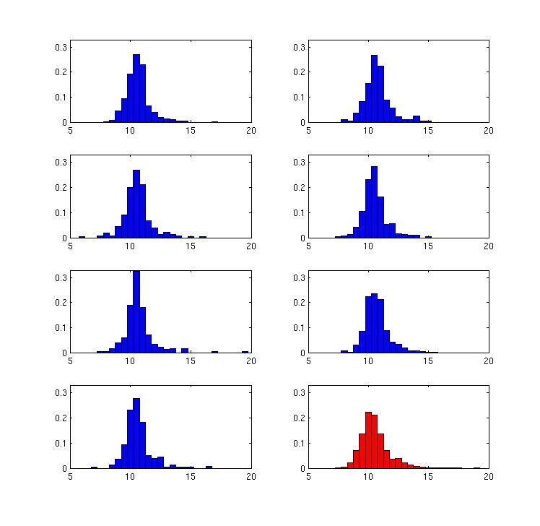

Figure : Distribution of Voronoi Cell log(areas) for the 7 individual observers (blue) and the model (red).

# General Discussion

The random walk model finds the target in a similar number of fixations as a typical human observer. Furthermore, the Voronoi method shows that model’s scan-paths are spatially distributed in a similar way as the human scan-paths. This suggests that human search behaviour can be, at least in the search task presented here, modelled using a simple data-driven stochastic process.

This is a somewhat surprising result given that Najemnik and Geisler have shown that human observers appear to be near optimal in their search strategy (2008). The main difference between our assumptions and theirs is that we assume an isotropic visibility map. However, it seems unlikely that taking $θ$ into account in our signal detection experiment would change the modelling results significantly. Najemnik and Geisler also compare the spatial locations of the fixations chosen by their ideal observer, a MAXP model, and human subjects and find that both human subjects and the ideal observer show a clear preference for fixation on small regions above and below the centre of the image. However, our empirical data does not agree with this: neither the empirical data from the human observers, or the stochastic search model, exhibit any particular preferences for fixating one regions over another.

## COnclusions

A complete (computational) visual search model should posses two parts: a feature extraction front end and a search strategy. Depending on the stimuli the feature extraction section can take the form of feature comparisons (Pomplun, Reingold, & Shen, 2003; Rutishauser & Koch, 2007) or an image processing algorithm (Rao, Zelinsky, Hayhoe, & Ballard, 2002; Pomplun M. , 2006; Clarke, Green, & Chantler, 2009). Previously implemented search strategies have generally worked in a serial manner, checking items one at a time, with some form of imperfect memory (Melloy, Das, Gramopadhye, & Duckowski, 2006; Rutishauser & Koch, 2007). While some variations allow for several items to be checked at once a common assumption is that the target can only be detected when it is in the image region currently under fixation. However there appears to be a growing consensus that although saccades and fixations impose a serial nature on search tasks, target detection can occur in parallel (Verghese, 2001; Najemnik & Geisler, 2005).

One search model that makes use of parallel target detection over a serial sequence of fixations is the Ideal Observer (Najemnik & Geisler, 2008). One problem with this approach is that it assumes that the target will be located at one of a predefined independent finite number of potential target locations. Unfortunately, this assumption breaks down when image processing techniques are used as the activation at any pixel is likely to be correlated with its neighbours. Hence we have explored an alternative explanation of human search strategies: a random walk.

While the use of a random walk to explain patterns of fixations is not new (Greene, 2008; Aks, Zelinsky, & Sprott, 2002; Morawski, Drury, & Karwan, 1980), our model is strongly based on empirical data. We find that a random walk behaves in a similar way to human observers, both in terms of the number of saccades required to find the target, and the spatial distribution.

Our results here suggest that inhibition of return; integration of information across fixations, and more general memory based processes have only a small role to play in search for a inconspicuous target on a homogeneous surface. We have used naturalistic, (pseudo)-continuous stimuli rather than arrays of abstract search items and found that there is little difference between the performance of our random walk model and that of human observers.

# Bibliography

Aks, D. (2005). 1/f dynamic in complex visual search: Evidence for Self-Organized Criticality in human perception. In M. A. Riley, & G. C. van Orden (Eds.), *Tutorials in comtemporary nonlinear methods for the behavioral sciences* (pp. 329-359).

Aks, D. J., Zelinsky, G., & Sprott, J. C. (2002). Memory across eye-movements: 1/f dynamic in visual search. *Journal of Non-linear Dynamics in Psychology & the Life Sciences* *, 6* (1), 1-25.

Arani, T., Karwan, M. H., & Drury, C. G. (1984). A Variable-Memory Model of Visual Search. *Human Factors* *, 26* (6), 631-639.

Clarke, A. D., Green, P. R., & Chantler, M. J. (2009).

Clarke, A. D., Green, P. R., Chantler, M. J., & Emrith, K. (2008). Visual Search for a Target Against a 1/f^β Continuous Textured Background. *Vision Research* *, 48* (21), 2193-2203.

Gao, D., Mahadevan, V., & Vasconcelos, N. (2008). On the plausibility of the disciminant center-surrond hypothesis for visual saliency. *Journal of Vision* *, 8* (7), 1-18.

Gilchrist, I. D., & Harvey, M. (2006). Evidence for a systematic component within scan paths in visual search. *Visual Cognition* *, 14*, 704-715.

Greene, H. H. (2008). Distance-from-target dynamics during visual search. *Vision Research* *, 48* (23-24), 2476-2484.

Itti, L., & Baldi, P. (2008). Bayesian suprise attracts human attention. *Vision Research* .

Itti, L., & Koch, C. (2000). A saliency-based search mechanism for overt and covert shifts of visual attention. *Vision Research* *, 40*, 1489-1506.

Melloy, B. J., Das, S., Gramopadhye, A. K., & Duckowski, A. T. (2006). A model of extended, semi-systematic visual search. *Human Factors* *, 48* (3), 540-554.

Morawski, T., Drury, C. G., & Karwan, M. H. (1980). Predicting Search Performance for Multiple Targets. *Human Factors* *, 22* (6), 707-718.

Motter, B. C., & Holsapple, J. W. (2001). Separating attention from chance in active visual search. In J. Braun, C. Koch, & J. Davis (Eds.), *Visual attention and neural circuits* (pp. 159-175). Cambridge, MA: MIT Press.

Motter, B. C., & Simoni, D. A. (2008). Changes in the functional visual field during search with and without eye movements. *Vision Research* *, 48*, 2382-2393.

Najemnik, J., & Geisler, W. S. (2008). Eye movement statistics in humans are consistent with an optimal search strategy. *Journal of Vision* *, 8* (3), 1-14.

Najemnik, J., & Geisler, W. S. (2005). Optimal eye movement strategies in visual search . *Nature* , 387-391.

Over, E. A., Hooge, I. T., & Erkelens, C. J. (2006). A quantitative measure for the uniformity of fixation density: The Voronoi method. *Behaviour Research Methods* *, 38* (2), 251-261.

Over, E. A., Hooge, I. T., Vlaskamp, B. N., & Erklens, C. J. (2007). Coarse-to-fine eye movements strategy in visual search. *Vision Research* *, 47*, 2272-2280.

Pomplun, M. (2006). Saccadic selectivity in complex visual search displays. *Vision Research* .

Pomplun, M., Reingold, E. M., & Shen, J. (2003). Area activation: a computational model of saccadic selectivity in visual search. *Congnitive Science* *, 27*, 299-312.

Rao, P. N., Zelinsky, G. J., Hayhoe, M. M., & Ballard, D. H. (2002). Eye movements in iconic visual search. *Vision Research* *, 42*, 1447-1463.

Reeves, A., Santhi, N., & DeCaro, S. (2005). A random-ray model for speed and accuracy in perceptual experiments. *Spatial Vision* , 73-83.

Rutishauser, U., & Koch, C. (2007). Probabilistic modeling of eye movement data during conjunction search via feature-based attention. *Journal of Vision* *, 7* (6), 1-20.

Stone, M. (1960). Models for choice-reation time. *Psychometrika* , 251-260.

Tavassoli, A., van der Linde, I., Bovik, A. C., & Cormack, L. K. (2009). Eye movements selective for spatial frequency and orientation during active vision search. *Vision Research* *, 49*, 173-181.

Tseng, Y. C., & Li, C. S. (2004). Oculomotor correlates of context-guided learning in visual search. *Perception & Psychophysics* *, 66* (8), 1363-1378.

Verghese, P. (2001). Visual Search and Attention: A Signal Detection Theory Approach. *Neuron* , 523-535.

Wolfe, J. M. (1994). Guided Search 2.0: A Revised Model of Visual Search. *Psychonomic Bulletin & Review* *, 1* (2), 202-238.

Wolfe, J. M. (2007). Guided Search 4.0: Current Progress with a model of visual search. In W. Gray (Ed.), *Integrated Models of Cognitive Systems* (pp. 99-119). New York: Oxford.

Wolfe, J. M., & Gancarz, G. (1997). Guided Search 3.0. In V. Lakshminarayanan (Ed.), *Basic and Clinical Applications of Vision Science* (pp. 189-192). Dordrecht, Netherlands: Kluwer Academic.

Wolfe, J. M., Cave, K. R., & Fransel, S. L. (1989). Guided Search: An alternative to the feature integration model for visual search. *Journal of Experimental Pschology: Human Perception and Performance* *, 15* (3), 419-433.

|  |  |
| --- | --- |
| humanVoronoiEx.jpg | humanVoronoiEx2.jpg |
| Randomwalk_Voronoicell1.jpg | Randomwalk_Voronoicell2.jpg |

Figure 12: Examples of Voronoi cells. Top row – two examples of fixations from searches by human observers. Bottom row – two examples of fixations chosen by the random model.

1. “Continuous” is used to distinguish the stimuli from those which contain discrete sets of search items. As the stimuli were displayed at a sufficiently high resolution, they could perhaps more accurately be described as “perceptually-continuous” despite being discrete at the pixel-level. [↑](#footnote-ref-2)